Shaping the Shoreline: The Story of the Hibiscus Coast"
Hibiscus Coast: A Heritage Carved by Land, Sea, and People"

Early Māori Settlement
The Hibiscus Coast has deep roots, with Māori communities settling in the area as early as the 13th century. The first inhabitants were part of Ngā Oho, with the region between the Ōrewa and Mahurangi rivers historically known as Mahurangi—named after a fortified pā once located near the Waiwera River. These early communities lived in close connection with the land and sea, relying on seasonal migration patterns and sophisticated knowledge of the environment to harvest food and resources.
Significant archaeological sites have been uncovered in places like Karepiro Bay, Shakespear Regional Park, and the Ōrewa Estuary. The estuary itself served as a vital harbour, offering plentiful seafood like shellfish and flounder, and linking to inland routes for seasonal travel and trade. The name "Ōrewa" is thought to mean “place of the rewarewa,” a native tree, and originally referred to the river, not the beach.
European Arrival and Early Industry
In 1827, French explorer Jules Dumont d'Urville charted the area, followed by a missionary landing in 1833. By the late 1830s, timber traders were exploring the forests around the Weiti River, drawn by the region’s abundant kauri trees. These towering giants were in high demand for shipbuilding and construction, making the Hibiscus Coast a focal point for logging operations. The area eventually became part of the Mahurangi land sale to the Crown in 1841, marking the beginning of significant European land ownership and development.
The Weiti River town, now known as Silverdale, was once called The Wade and served as a hub for the local logging trade. Timber was transported downriver to waiting ships, creating a bustling economic centre. Waiwera, with its natural thermal springs, started attracting visitors in the late 1800s. Word of the hot pools spread, and the area gained a reputation as a wellness retreat, drawing day-trippers and tourists seeking rest and rejuvenation.
Development of Orewa
Captain Isaac Rhodes Cooper purchased land in 1856 and built a cottage near the northern end of what is now Ōrewa. In 1868, the de Jersey Grut family from the Channel Islands took over the property and expanded it into a gracious home known as Orewa House, famed for its hospitality. The house served as a social centre for visitors and locals, offering hearty meals and warm welcomes. It later became a guest house and remained in operation until its subdivision in the mid-20th century, hosting holidaymakers in an idyllic coastal setting.
As kauri resources declined, the land was turned into orchards and, by the 1920s, into productive dairy farms. Fruit such as apples, grapes, and citrus were grown to meet demand in the Auckland market, while dairy farming became the region’s economic backbone. By this time, Ōrewa had also gained popularity as a camping and holiday destination. Families set up tents along the beachfront during summer, drawn by the natural beauty, swimming opportunities, and relaxed pace of life.
A Growing Community
During World War II, the Whangaparāoa Peninsula hosted a New Zealand Army base, bringing increased infrastructure and attention to the area. The post-war years brought rapid development, particularly after the opening of the Auckland Harbour Bridge in 1959. This new connection spurred urban growth, making commuting to Auckland more feasible and attracting new residents looking for a lifestyle change. Suburban subdivisions appeared across Ōrewa and Whangaparāoa, offering housing with sea views and space to breathe.
Town centres emerged to serve the growing population. Hillary Square and surrounding shops opened in 1953, creating a commercial heart for Ōrewa. Public amenities, schools, and transport services followed, reflecting the region’s transformation from a rural retreat to a bustling community. Recreational venues, like the Orewa Skating Rink built in 1957, offered social spaces for families and teenagers alike. The site evolved into an entertainment precinct, complete with mini-golf and concert stages, before being replaced in the 1980s.
A Name to Reflect the Lifestyle
In the 1960s, local business leaders chose the name “Hibiscus Coast” to evoke a warm, beachy appeal fitting of the area’s laid-back lifestyle. The name was selected to unify the communities of Whangaparāoa and Ōrewa under a shared identity that spoke to both locals and visitors. Hibiscus flowers, although not native, were seen as a symbol of leisure and tropical charm. More than a thousand were planted throughout the area in 1964 to reinforce this branding.
The name caught on quickly. The Hibiscus Coast Association was formed soon after to promote the region and protect the use of the hibiscus symbol from being adopted by other districts. In 1971, the name was officially recognised, cementing the coast’s place on the map as a welcoming and vibrant destination with a distinct personality.
Modern-Day Connections
With the extension of the Northern Motorway to Silverdale in 1999, the Hibiscus Coast became more connected than ever to Auckland. This major infrastructure project cut travel times and opened the door to continued residential and commercial development. The motorway link allowed more people to enjoy the best of both worlds—a quieter coastal lifestyle without sacrificing access to the city.
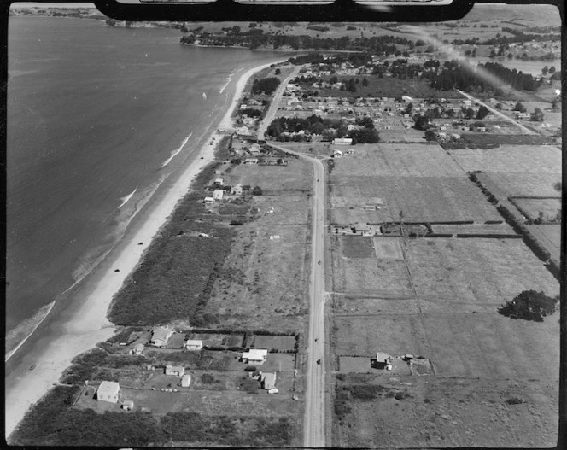
Today, the Hibiscus Coast is thriving, balancing natural beauty with modern conveniences. New developments, regional parks, and a strong sense of community make it a popular place for those seeking an active, outdoors-oriented lifestyle. Whether you're strolling the beach, exploring local markets, or taking part in community events, the coast offers something for everyone to enjoy.

Orewa. Whites Aviation Ltd: Photographs. Ref: WA-26159-F. Alexander Turnbull Library

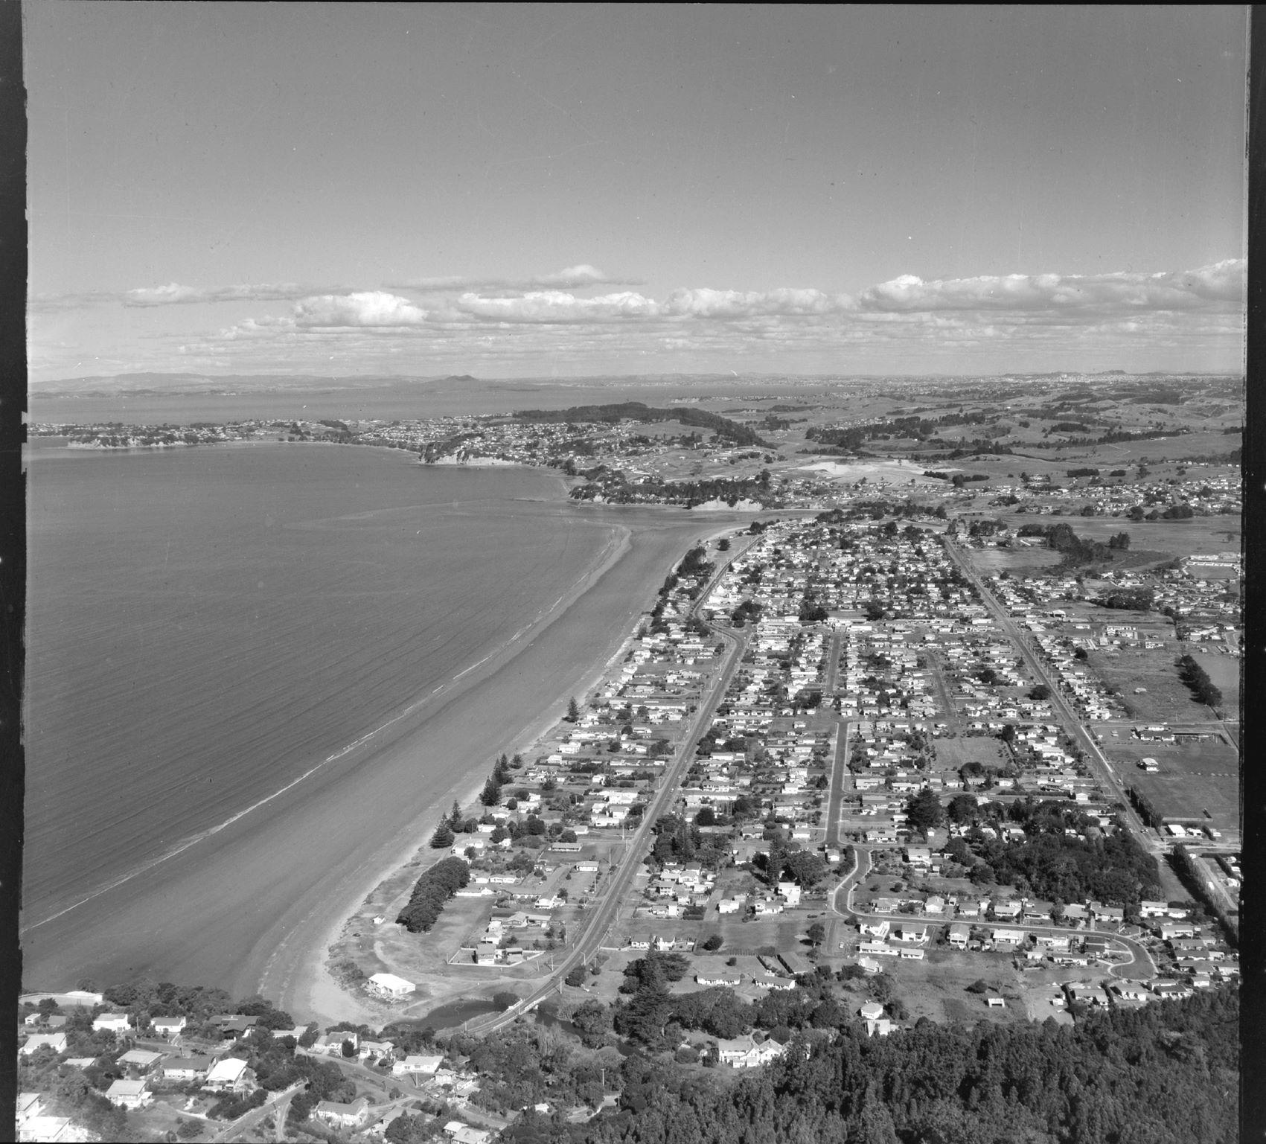

Orewa, Rodney County, Auckland. 2 Apr 1976
Aerial photograph taken by Whites Aviation.
Alexander Turnbull Library, Wellington, New Zealand.

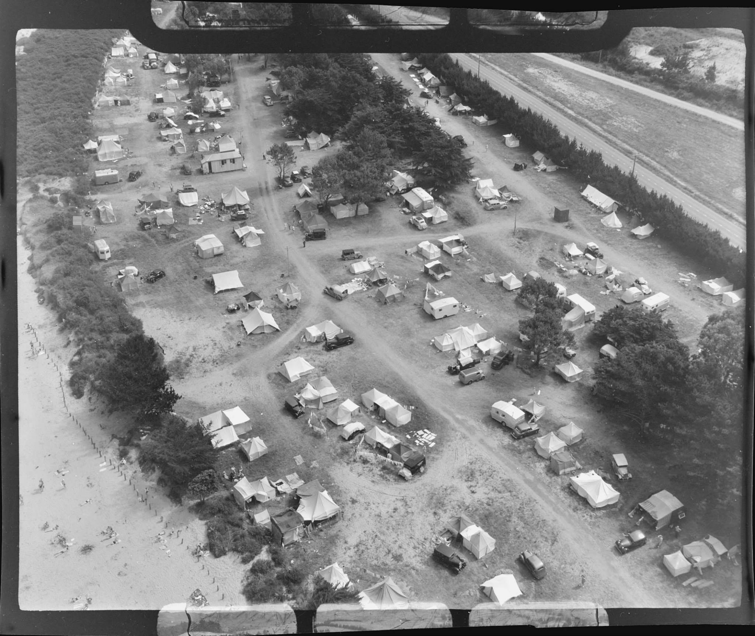

Motor camp, Orewa Beach, Rodney District, Auckland. 3 Jan 1951
Aerial photograph taken by Whites Aviation.
Alexander Turnbull Library, Wellington, New Zealand.

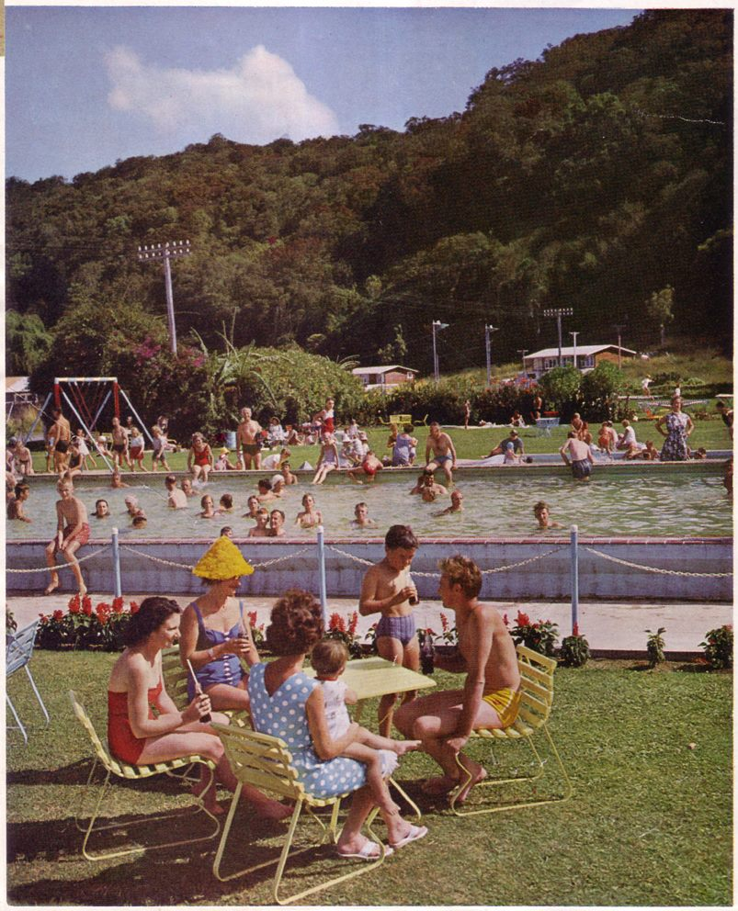

Summer visitors at Waiwera, north of Auckland. Two pools, one warmer than the other and only a few yards from the beach, are set in lawns and picnic grounds.
Taken from the “Weekly News Annual” published by Wilson & Horton. 1964.

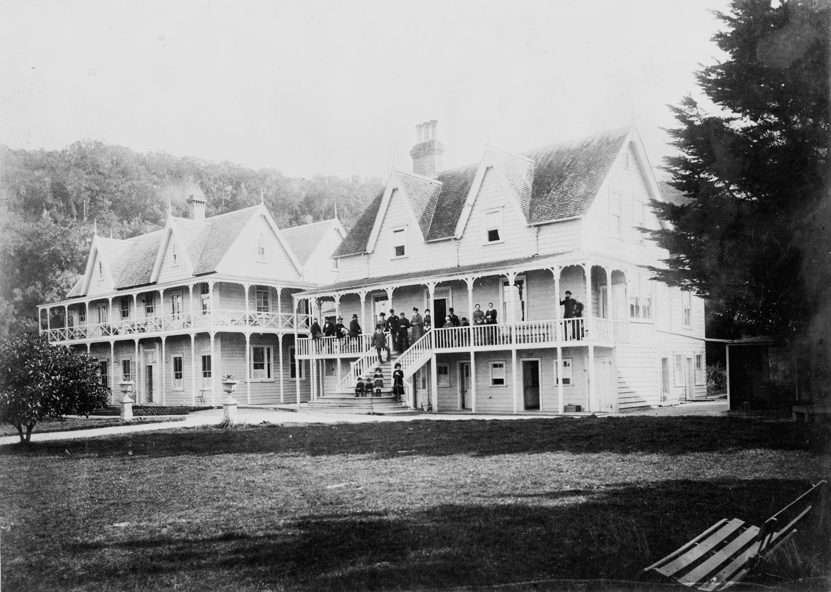
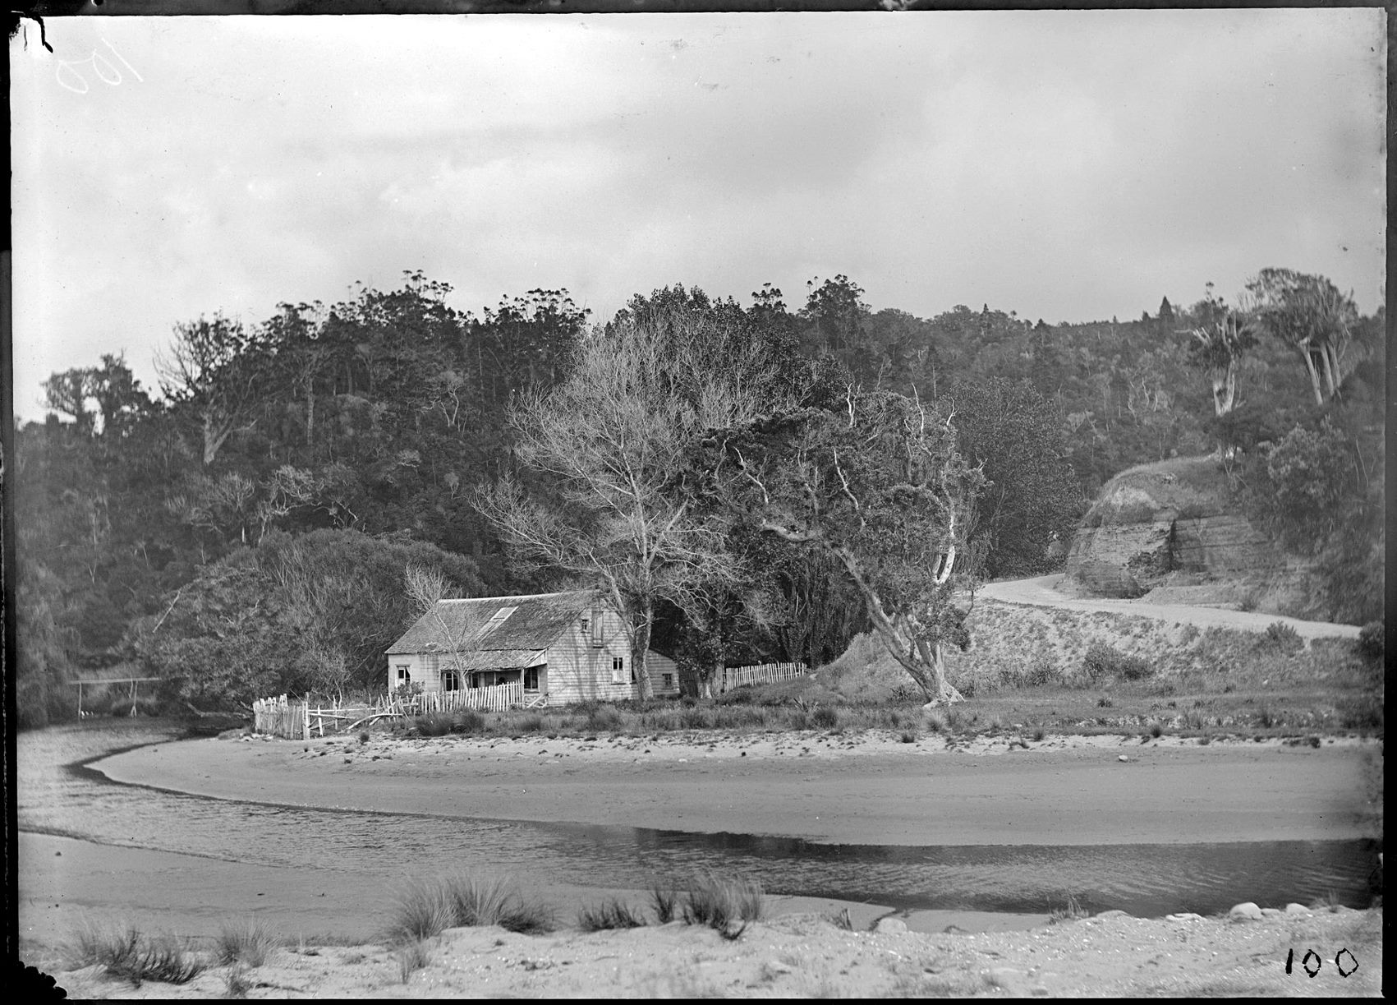
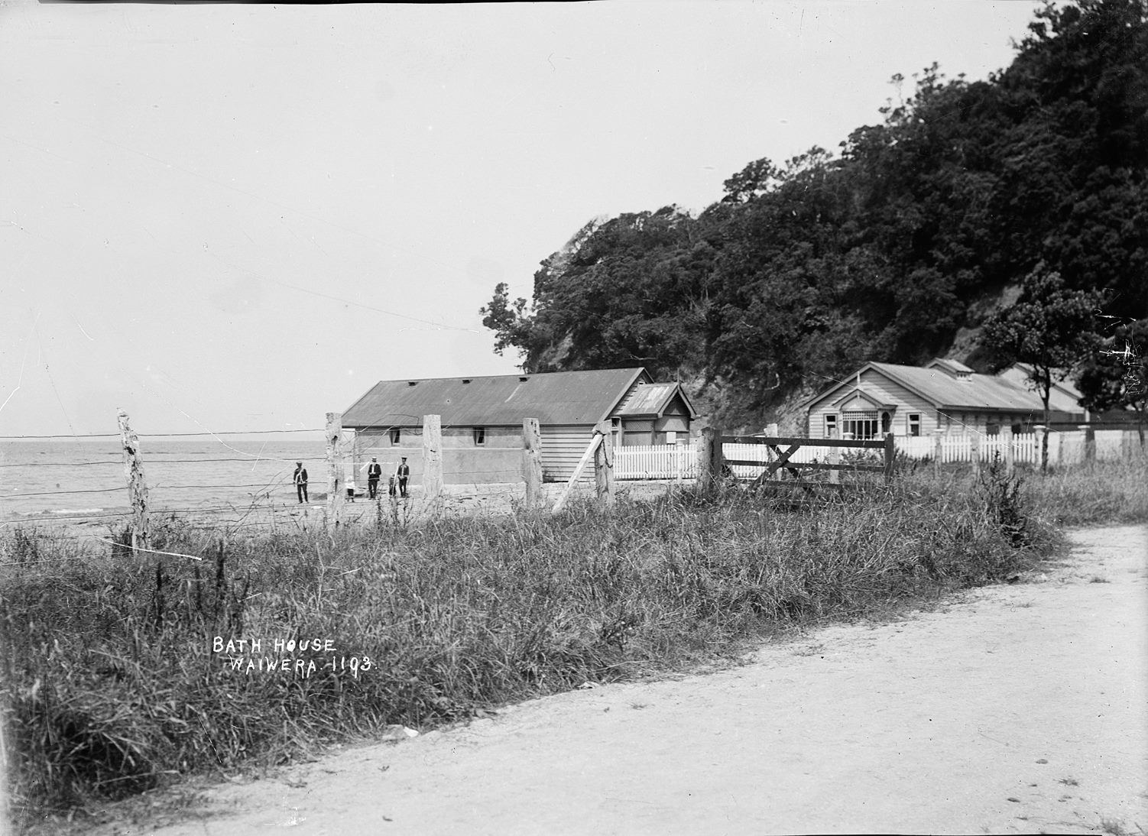
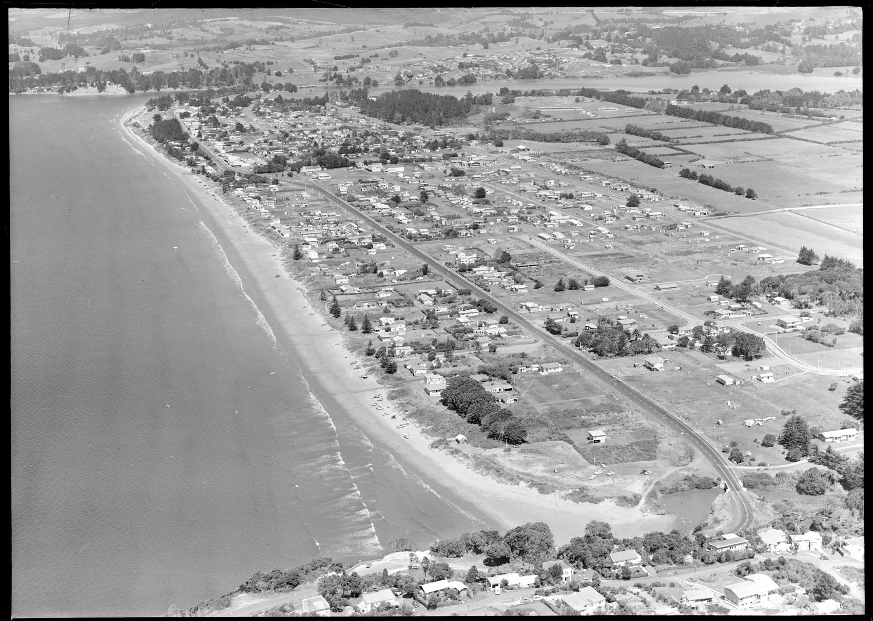
Waiwera Hotel in the 1880s. Taken by an unidentified photographer.

Alexander Turnbull Library, Wellington, New Zealand

House beside Otanerua Creek, Orewa, Rodney District, including native trees, road and dunes. between 1880 and 1899.
Photograph taken by Daniel Manders Beere.

Alexander Turnbull Library, Wellington, New Zealand.
View of the bath houses on the beach and near the Hot Springs Hotel at Waiwera. Taken from the roadway looking south-east towards the beach, with the sea in the background.

Photograph taken by William A Price in early 1900s.

National Library NZ.
Orewa, 3 March 1963.
Aerial photograph taken by Whites Aviation.
Alexander Turnbull Library, Wellington, New Zealand.

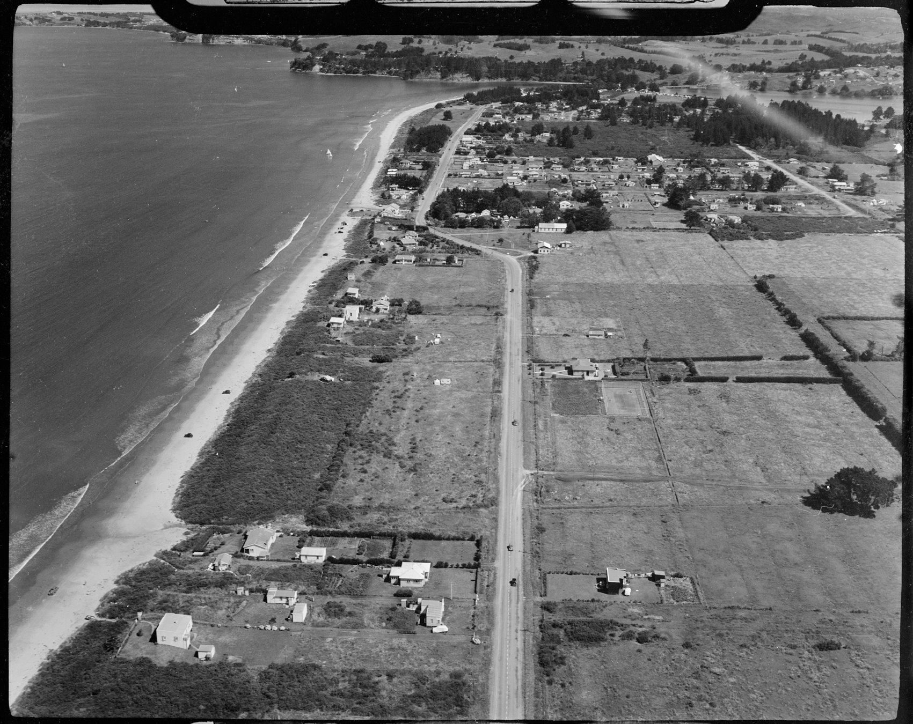

Aerial view of Orewa, taken 3 January 1951 by Whites Aviation.
Alexander Turnbull Library, Wellington, New Zealand.

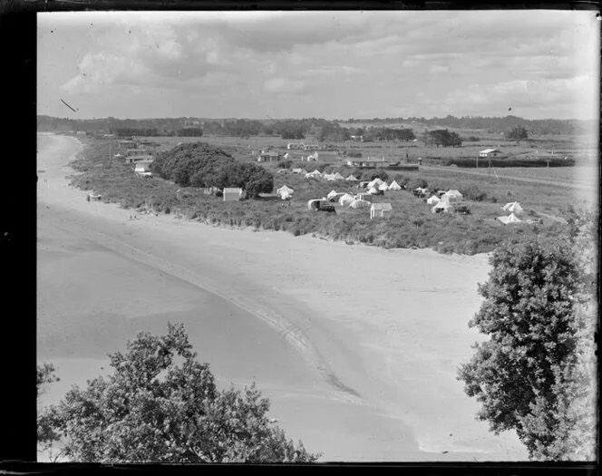

View of Orewa beach, with tents pitched beside the sand. Whites Aviation Ltd: Photographs. Ref: WA-09240-G. Alexander Turnbull Library, Wellington, New Zealand

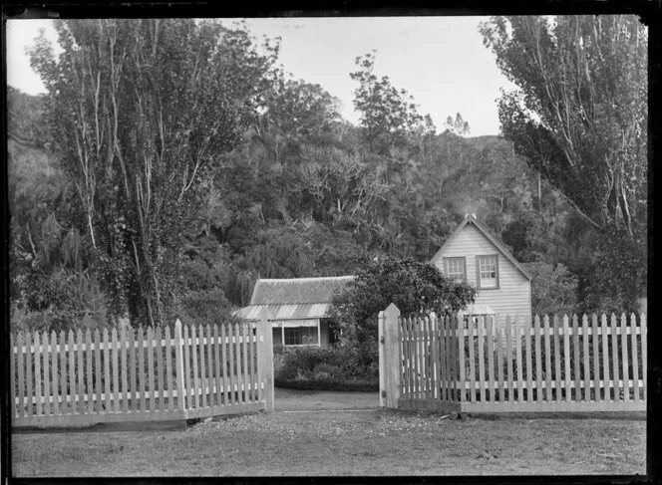

Front view of Major De Grut's house, Orewa, Rodney District, including native trees and fence. Beere, Daniel Manders, 1833-1909 :Negatives of New Zealand and Australia. Ref: 1/2-096235-G. Alexander Turnbull Library,
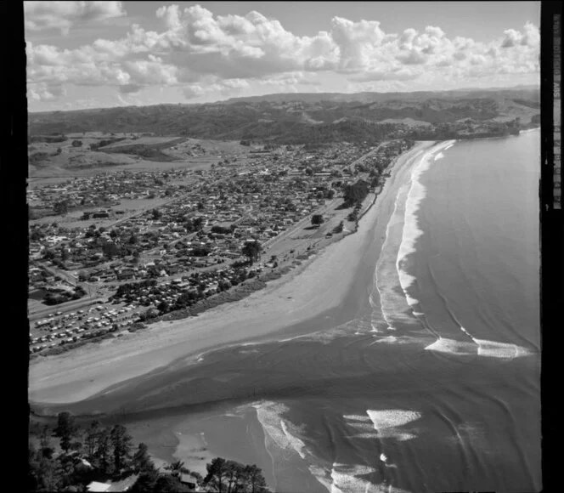

Orewa, Rodney District, Auckland. Whites Aviation Ltd: Photographs. Ref: WA-77562-F. Alexander Turnbull Library, Wellington, New Zealand.

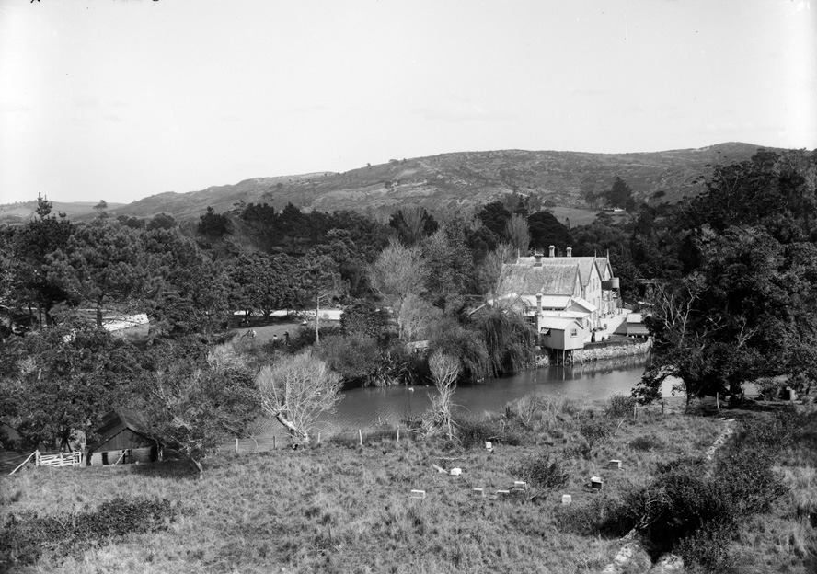

Rear of Grut Brothers Boarding house (now Orewa House next to Walnut Cottage) 1906

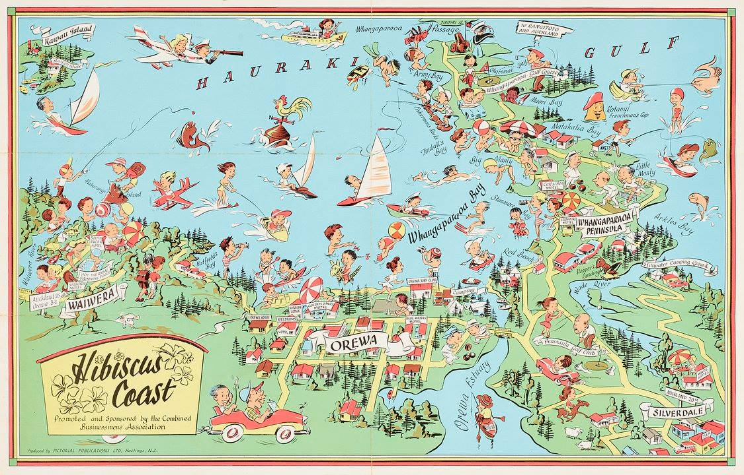
Early tourist mp of Orewa and Hibiscus Coast, 1960

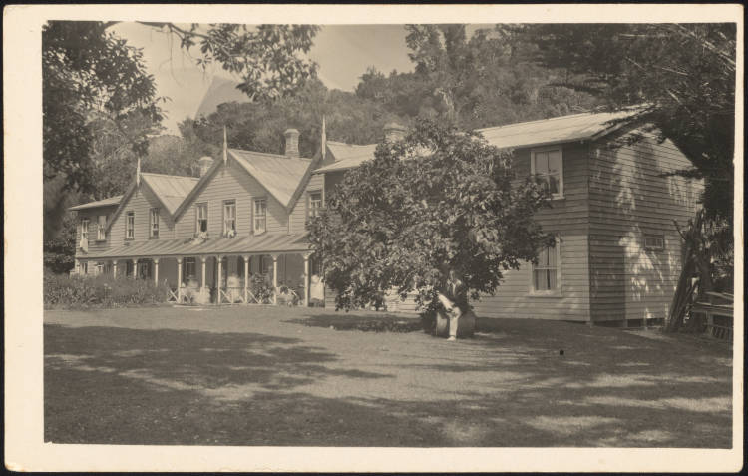
Eaves Boarding House (Orewa House), with a man sitting on a roller, smoking a pipe, in the foreground. The house was originally owned by Major Grut, and then bought by Edward and Alice Eaves who ran it as a boarding house. Auckland Libraries Heritage Collections 898-0055
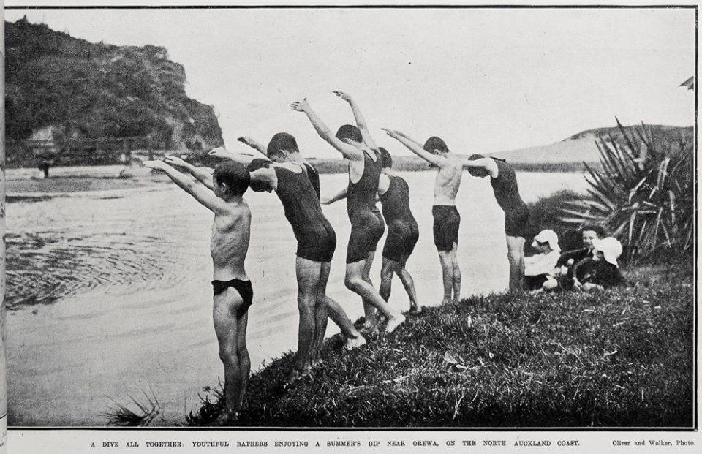

swimmers diving into the Orewa Estuary, 1920

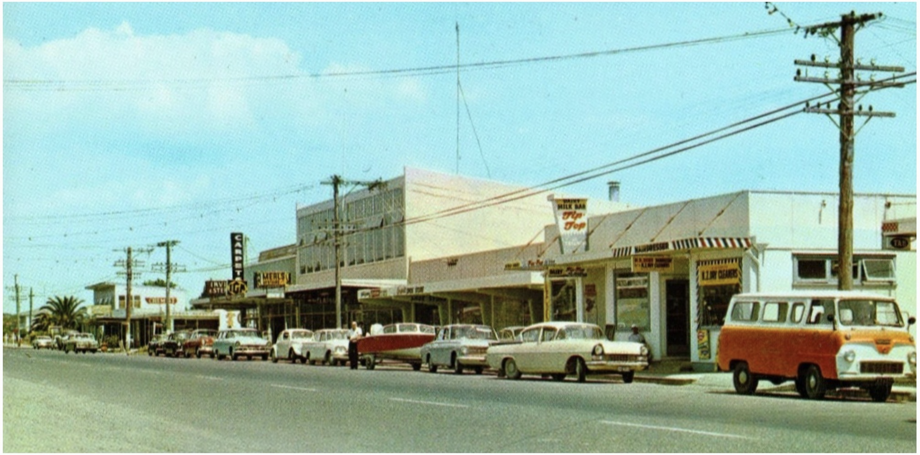
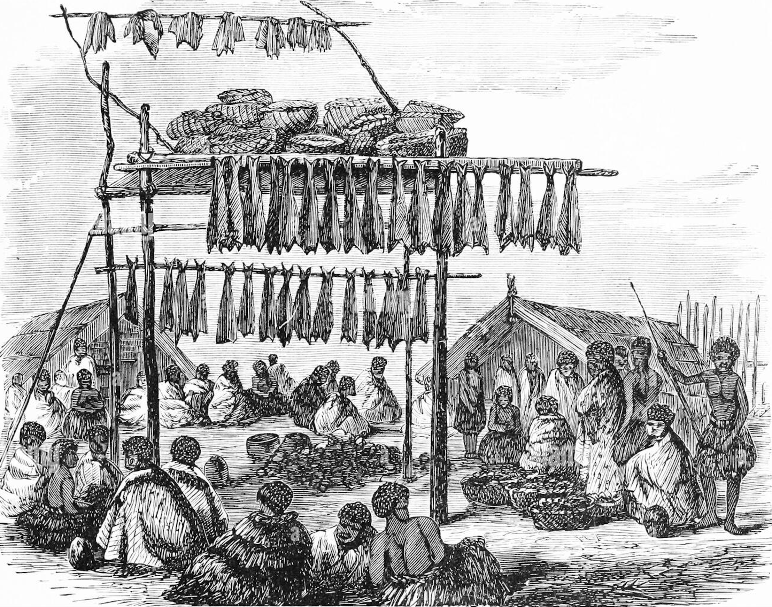
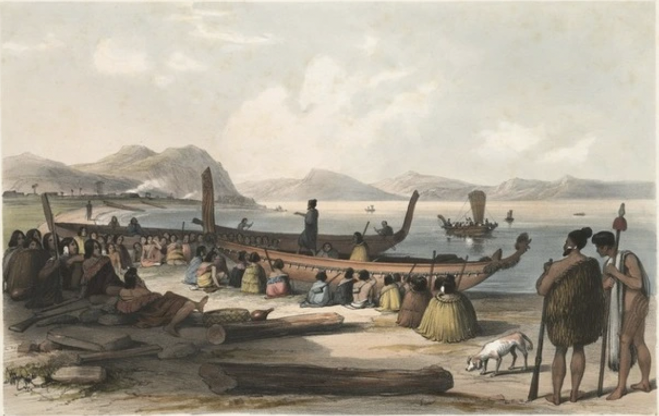
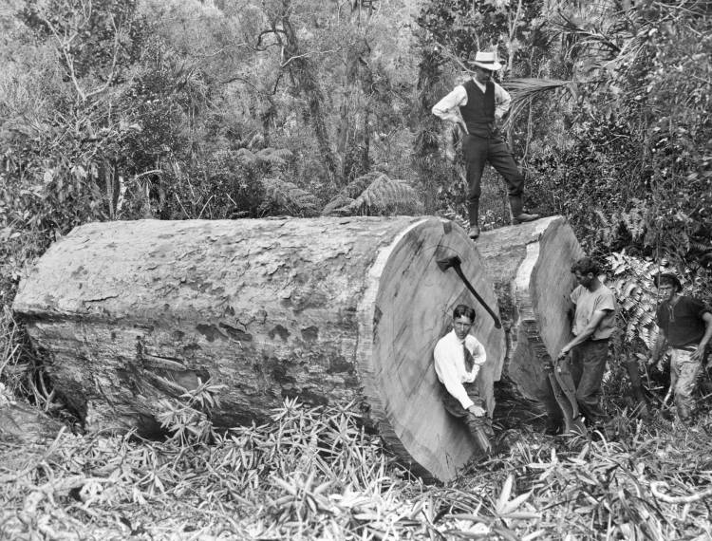
Alexander Turnbull Library no. APG-0423-1/2-.Alexander Turnbull Library
vintage postcard of Orewa shops along Hibiscus Highway, photographed by Gladys Goodall for Whitcombe and Tombs in the late 1960s.
A Maori pa, with fish drying on racks in a book written in 1871 by John George Wood, and published by J. B. Burr and company
Earle, Augustus, 1793-1838 :War speech. London, R. Martin & Co. 1838.
Kauri Logging Gang. 1916. Photgrapher. Godber, Albert Percy, 1875-1949
.Alexander Turnbull Library no. APG-0423-1/2-G

